**Department of _Computer Science and Engineering**

**MIT SCHOOL OF COMPUTING**

**MIT ADT University, Loni Kalbhor, Pune**

**Instructions for B.Tech. Project Report Writing**

* Project Report should include necessary certificates, acknowledgment, tables, list of diagrams, abstract, annexure (i.e., Paper), index.(pages from 60 to 90)
* If particular part is repeated, you can mention “Refer Page No. and point” or “Refer Annex
* Prepare at least **n + 2 Project Report** copies of your manuscripts for student, Guide, Department, University/Library. Submit soft copy in CD.
* Acknowledgment, List of Publications, List of Diagrams, List of Tables, Abstract should have page nos I, II, III, IV respectively.
* Always place the images/Diagrams/Table at the beginning or end of the page.
* The footer “**MITSOC, Department of Computer Engineering <year YYYY>**” should be included. (10, Times Roman, Center justified) from Introduction page
* Main part of manuscripts should be **Times Roman, 12 pts, justified** and **1.5 line spacing**(Should be Printed on both side of paper)
* Use paper size **8.5” x 11”** or **A4** (210 x 197 mm). Follow following margins.

|  |  |  |  |
| --- | --- | --- | --- |
| **Margin** | **Paper A4** | **Margin** | **Paper A4** |
| Top | 1” | Bottom | 1 |
| Left | 1.25 | Right | 1 “ |

All paragraphs will be single **line spaced** with a 1.5 line **space** between each paragraph. Each paragraph will begin with a **two-space indentation.**

* Chapter **titles** should be **bold** with **18 pt** typed in all **CAPITALS** letters and should be aligning at the **center** of the page.
* **Section heading** should be aligning at the **left** with **12 pt** and **bold** and **capitalized**.
* Section **subheading** should be aligning at the **left** with **title case.**
* Leave **one** spaces between section heading and **10 pt** space between two-section subheadings.
* References should be in IEEE format, in the order as they **appear in the dissertation**.
* Symbols and notations if any should be included in nomenclature section only.
* All chapters, section heading and sub headings should be numbered. For chapter use numbers 1,2,3 and for sub headings 1.1, 1.2, 1.3. And section subheadings 2.1.1, 2.1.2 etc.

The text should be typed on both side of the paper.

(Hard bound blue cover page with golden embossing)

*(Four blank spaces)*

**A PROJECT REPORT ON**

(14/bold, upper case)

*(One blank spaces)*

**YOUR PROJECT TITLE GOES HERE**

(18/bold, upper case)

*(Two blank spaces)*

SUBMITTED TO

MIT SCHOOL OF COMPUTING, LONI, PUNE IN PARTIAL FULFILLMENT OF THE REQUIREMENTS FOR THE AWARD OF THE DEGREE

(12,upper case)

*(Four blank spaces)*

**BACHELOR OF TECHNOLOGY**

**(Computer Science & Engineering)**

(14/bold, upper case)

*(Two blank spaces)*

**BY**

(14, bold/upper case)

*(Two blank spaces)*

Candidate Name PRN/ Enrollment No: -----

*(Two blank spaces)*

**Under the guidance of**

*(One blank spaces)*

(14/bold, upper case)

Prof/Dr/……………

*(one blank spaces)*



*(one blank spaces)*

**DEPARTMENT OF COMPUTER SCIENCE AND ENGINEERING**

*(Two blank spaces)*

**MIT School OF COMPUTING**

**MIT Art, Design and Technology University**

**Rajbaug Campus, Loni-Kalbhor, Pune 412201**

*(One blank spaces)*

**20__- __**



**MIT SCHOOL OF COMPUTING**

**DEPARTMENT OF COMPUTER SCIENCE AND ENGINEERING**

MIT ART, DESIGN AND TECHNOLOGY UNIVERSITY,

RAJBAUG CAMPUS, LONI-KALBHOR, PUNE 412201

(16, bold, upper case)

*(Two blank spaces)*

**CERTIFICATE**

(16, bold, upper case)

*(Two blank spaces)*

This is to certify that the project report entitled (12, sentence case) *(One blank space)*

**“YOUR PROJECT TITLE GOES HERE”** (12, bold, upper case)*(Two blank spaces)*

Submitted by

*(One blank space)*

Name of the Candidate PRN/ Enrollment No: -----

(12, Title case)

*(One blank space)*

is a bonafide work carried out by them under the supervision of Prof./Dr/ ….. and it is submitted towards the partial fulfillment of the requirement of MIT ADT university, Pune for the award of the degree of Bachelor of Technology (Computer Science and Engineering) (12, Sentence case)

*(Four blank spaces)*

**Prof. PQR Dr.xyz**

Guide Head of Department

**Dr. ABC Dr. DEF**

Director Dean

Seal/Stamp of the College

Place: PUNE

Date:

**On Company Letter head/seal**

**CERTIFICATE** (16, bold/upper case)

*(Three blank spaces)*

This is to certify that the Project report entitled (12, sentence case)

*(One blank space)*

**“YOUR PROJECT REPORT TITLE GOES HERE”** (12, bold/upper case)

*(Two blank spaces)*

Submitted by

*(One blank space)*

Name of the Candidate Exam No: ---------------------

(12, Title case)

*(One blank space)*

is a bonafide work carried out by him/her (with the Sponsorship from ------------) under the supervision of Mr/Ms/Miss. ………………………….. and has been completed successfully.

*(Four blank spaces)*

(Mr. ……………… )

(Designation)

External Guide

(12, Sentence case) Seal/Stamp of the Company/College

Place :

Date :

*(one blank spaces)*

**DECLARATION**(16, bold/upper case)

*(Three blank spaces)*

We, the team members

|  |  |
| --- | --- |
| Name | Enrollment No |
| Abhijeet Jangale | (MITU17BTCS0092) |
| Minakshi Mittal | (MITU17BTCS0127) |
| Tanishqa Chaudhary | (MITU17BTCS0035) |

Hereby declare that the project work incorporated in the present project entitled **“Your Project Title Goes Here”** is original work. This work (in part or in full) has not been submitted to any University for the award or a Degree or a Diploma. We have properly acknowledged the material collected from secondary sources wherever required. We solely own the responsibility for the originality of the entire content.

Date: 19/07/2021

Name & Signature of the Team Members

Member 1: __________________

Member 2: __________________

Member 3: __________________

**Name and Signature of Guide**

Seal/Stamp of the College

Place: Pune

Date: 19/07/2021



DEPARTMENT OF COMPUTER SCIENCE & ENGINEERING

MIT SCHOOL OF COMPUTING,

RAJBAUG, LONI KALBHOR,

PUNE – 412201

*(Three blank spaces)*

**EXAMINER’S APPROVAL CERTIFICATE**(16, bold/upper case)

*(Three blank spaces)*

The project report entitled “TITLE OF THE PROJECT” submitted by Student 1 (MITU17BTCS00xx), Student 2 (MITU17BTCS01xx), Student 3 (MITU17BTCS00xx) in partial fulfillment for the award of the degree of Bachelor of Technology (Computer Science & Engineering) during the academic year 2021-22, of MIT-ADT University, MIT School OF COMPUTING, Pune, is hereby approved.

**Examiners:**

**1.**

**2.**

*(one blank spaces)*

**ACKNOWLEDGEMENT**(16, bold/upper case)

*(Three blank spaces)*

*Student have to fill by their own*

**Name, Enrollment No.**

*(one blank spaces)*

**ABSTRACT**(16, bold/upper case)

*(Three blank spaces)*

*In India, the rate of unemployment is on an upsurge. Due to the COVID-19 pandemic, many people are facing salary cuts, job loss, etc. The main objective of this project is to improve*

*(one blank spaces)*

**CONTENTS**(16, bold/upper case)

*(Three blank spaces)*

|  |  |
| --- | --- |
| Certificate ………………....………………………….…………. | i |
| Certificate (From Company If Any) …………………...………. | ii |
| Declaration ……………….…………….………………....………. | iii |
| Examiner’s Approval Certificate …………………………………. | iv |
| Acknowledgement ……………….…………………..……………. | v |
| Abstract …………………………………………..…...……………. | vi |
| List of Figures ………………………..………….…………………. | viii |
| List of Tables ……………………….…………….…………………. | ix |

Chapter 1 INTRODUCTION 1

1. Introduction 1

1.1 Digitalization in Labor Market: 2

2. Existing Work 3

3. Motivation 3

4. Objectives 4

5. Scope 4

Chapter 2 CONCEPTS AND METHODS 5

2.1 definitions 5

Chapter 3 LITERATURE SURVEY 7

Chapter 4 PROJECT PLAN 10

Chapter 5 SOFTWARE REQUIREMENT SPECIFICATION 11

5.1 Project scope 11

5.2 User Classes & Characteristics Coder 11

Chapter 6 RESULTS 12

Chapter 7 SOFTWARE TESTING 13

Chapter 8 CONCLUSION AND FUTURE WORK 14

BIBLIOGRAPHY 15

ANNEXURE A: List of Publications and Research Paper (In its Original formats) 16

ANNEXURE B: Plagiarism Report 17

ANNEXURE C: Empathy Chart and Solution Document

Annexure D: Project Tracker

*(one blank spaces)*

**LIST OF FIGURES**(16, bold/upper case)

*(Three blank spaces)*

|  |
| --- |
| Figure Number: Figure of the table Page Number |

Figure 2.1: This is my First Figure 6

Figure 4.1: Software modeling 10

*(one blank spaces)*

**LIST OF TABLES**(16, bold/upper case)

*(Three blank spaces)*

|  |
| --- |
| Table Number: Title of the table Page Number |

Table 1:1: This is my First Table 3

Table 3:1: Literature Survey 9

*(one blank spaces)*

# INTRODUCTION

*(one blank spaces)*

## Introduction

The conventional idea of "labor" as referring to the everyday grind is giving way to a more liberated manner of working, aided by ever-increasing technology, which threatens to substitute labor as we have known it for centuries. Bots, or software meant to automate particular processes, are the most apparent and popular expression of attempts to imitate ordinary human interactions like scheduling meetings and finding flight and hotel pricing, to name a few. Bots will become more sophisticated monsters as the technology matures, capable of disrupting even more cognitive jobs currently handled by humans.[1]

The incredible rise of the Internet, dubbed the Fourth Industrial Revolution recently, is impacting practically every business in every country. The magnitude and scope of these changes are indicative of the ongoing transformation of the entire production, management, and governance systems, which occurs only infrequently. It's one of those watershed times in history that could cause yet another labor market upset and fundamentally reshape how we work.

So, with the rapid unemployment rate, employee dissatisfaction, employees hopping between jobs & the rise of entrepreneurship, the concept or the culture of freelancing is slowly capturing people’s attention. Due to COVID-19, many people were forced out of their jobs and with the economy falling for India there are very few opportunities for the youth of our nation to showcase their skills and to earn a decent amount.[2]

The fact that most of the youths are looking forward to learning new things, exploring more work-related genres & wishing to change jobs/career paths can also be considered as a factor for freelancing coming under the limelight. The future of freelancing in the country looks promising. Many individuals choose to work the way they want, where they want, and what they want to work on. The freelance stats are estimated to go up to

$20 to $30 billion by the end of 2025!

Around 15 million people in India are freelancing as of 2020 majorly working in sectors of IT, Sales, Marketing, Finance, etc. If we go according to Wikipedia, around 50% of the employees would be freelancing by 2025. But the payment received by freelancers in India is comparatively less than that of other countries. College students also get encouraged by the culture of freelancing and aspire to become one to secure some funds during their courses.

### 1.1 Digitalization in Labor Market:

Bots and Artificial Intelligence (AI) have given rise to new career prospects in traditional sectors. Technology has produced jobs, according to a new Deloitte research, particularly in knowledge-intensive industries like medical, education, and other professional services. It is, however, erroneous to believe that technology is merely a privilege for the educated and an opportunity for the unemployed. Technology is not only producing jobs for the less educated, but it is also giving informal workers the ability to use technology and digital platforms in their work. Multiple definitions exist for the informal labor market[2]; certain features (also mentioned above) are distinguishable, including whether employees are taxable, have access to social safety or insurance services, whether they have minimal salaries, etc.[3]

The development of online freelancing and microwork as rewarding prospects in the informal labor market of mainly India. During the processes, the digitally empowered workforce seeks employment and maximizes productivity on a continuum of rough to complicated corporate processes. The range of work includes heterogeneity of skills, experience, work planning preference, etc. In reality, research has shown that firms can eliminate inefficiencies and lower costs by creating an organization that creates a dual job market, a combination of highly paid employees and lesser paid self-employed specialist skills.[4]

## Existing Work

There are a few existing systems related to our project field. After some research and analysis, we came across the methodology of the system and a few of its drawbacks. The below table gives us the gist about these existing systems:-

**Table STYLEREF 1 \s 1: SEQ Table \* ARABIC \s 1 1: This is my First Table**

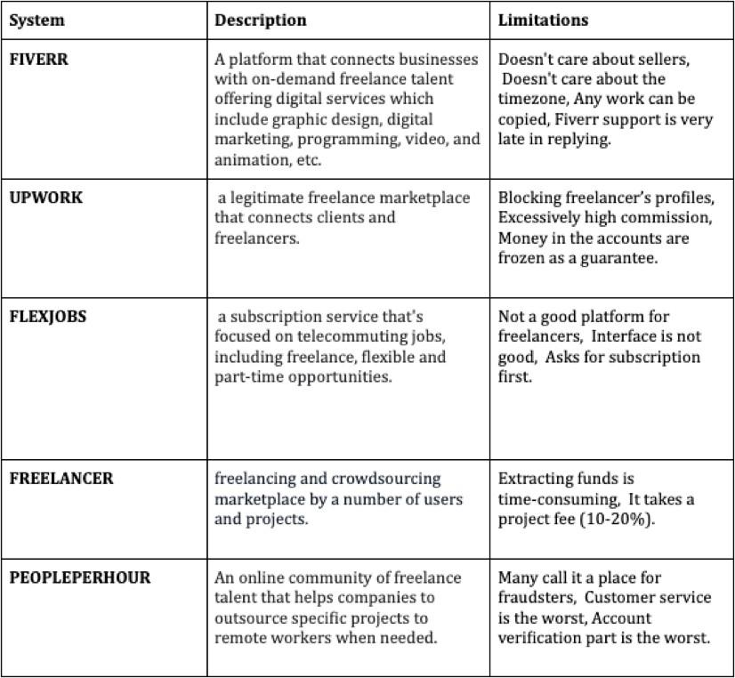

## Motivation

As it’s said, “No country, however rich, can afford the waste of its human resources”. Butin India, the unemployment rate is increasing day by day. And now, due to COVID-19 many people were forced out of their jobs and the opportunities for the youth of our nation to showcase their skills and to earn a decent amount has decreased.[5]

The main motivation behind this project is different though. Being a student first & an engineer, we know how financially unstable we are. Also, throughout our degree programme we make multiple projects which, atlas end up in our storage and become useless. So, Code-n-Mingle is that platform on which students can become financially self dependent upto an extent and can develop some new skills.

Since, the final solution for unemployment is work, in future, Code-n-Mingle will take an initiative to provide the right platform to the young and experienced freelancers so that their work is valued. Our system is dedicated to provide the user with a web interface to sell, buy or develop their projects & ideas. Code-n-Mingle will bring coders and buyers on a single platform. No doubt there is a freelance market in India, but due to less value and less job opportunities it has more of an **online labour market.**

## Objectives

* In support of the New Education Policy 2020, this can be a platform for exposure for students who learn to code and build applications/software with their ideas.
* To make students self-dependent with the help of the work they’ll do.
* To provide a platform to freelancers or working professionals.
* The platform Code-n-Mingle will allow people with no or fewer skills in buying and developing their unique ideas.

## Scope

* The proposed work aims to answer these questions :
* The coders can bid for a particular project for development or they also are able to upload their own projects and sell it according to their own bidding price.
* Buyers are able to upload a project for development and also buy the coder’s existing projects
* Code-n-Mingle focuses on equality of both the parties involved in the deal while being slightly biased towards the coders so as to avoid a lesser pay grade scale.

*(one blank spaces)*

# CONCEPTS AND METHODS

*(one blank spaces)*

## 2.1 definitions

**REACT:** React is a JavaScript library for creating interactive as well as fast user interfaces for web and mobile apps. It's a component-based, open-source front-end library that's just responsible for the application's view layer. The view layer is in charge of how the program looks and feels in the Model View Controller (MVC) architecture.

**Mongoose:** Mongoose is a MongoDB and Node.js Object Data Modeling (ODM) framework. It manages data associations, does schema validation, and is used to translate between objects in code and their MongoDB representations.

**MongoDB:** MongoDB is a NoSQL document database with no schema. It means you can store JSON documents in it, and the structure of these documents isn't constrained like in SQL databases. One of the benefits of utilizing NoSQL is that it speeds up application development and minimizes deployment complexity.

**Node.js:** is a cross-platform runtime environment for building server-side and networking applications that is free source. Node.js apps are written in JavaScript and run on OS X, Microsoft Windows, and Linux using the Node.js runtime. Node.js also comes with a large library of JavaScript modules, which greatly facilitates the building of Node.js web applications.

**Express:** Express is a Node.js web application framework that offers a comprehensive range of functionality for both web and mobile apps. [6]

**JSON:** JSON (JavaScript Object Notation) is a text-based standard for encoding structured data that is based on JavaScript object syntax. It's often used in web applications to convey data (e.g., sending some data from the server to the client, so it can

We group these four situations under the umbrella of online freelancing. While the images show platforms playing a key part in managing freelancer payments, in many cases, platforms' involvement is restricted to matchmaking for which they collect a fee. This is an expansion of the original use case of mobile and Internet technology and its application to the business of bringing customers and sellers together.

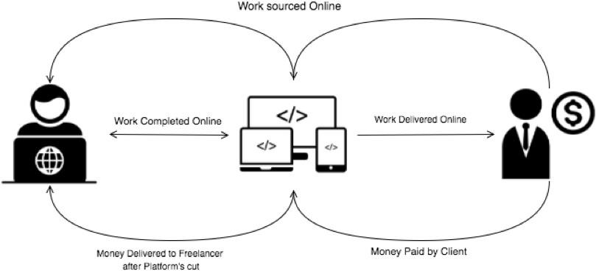

**Figure STYLEREF 1 \s 2. SEQ Figure \* ARABIC \s 1 1: This is my First Figure**

*(one blank spaces)*

# LITERATURE SURVEY

*(one blank spaces)*

ARIFIN, Riscal; DANIAWAN, Benny; WIJAYA, Dellih. Freelancer’s E-Marketplace Information System Using Profile Matching Method. Tech-E, [S.l.], v. talks about how the e-marketplace information system can increase freelancer revenue and the level of customer convenience in finding workers according to what is needed and can make the transaction process efficient and effective. As a result, it helps provide decision criteria for client selection.

Abhinav, Kumar & Dubey, Alpana & Jain, Sakshi & Virdi, Gurdeep. (2017). CrowdAdvisor: A Framework for Freelancer Assessment in Online Marketplace. 10.1109/ICSE-SEIP.2017.23. talks about a few multidimensional assessment frameworks which evaluate freelancers on several dimensions and uses the present information about the freelancer, therefore, utilizes the past jobs he has performed. The framework is evaluated on the info collected from a well-liked online marketplace. A report shows that the assessment made by the proposed framework surpasses the baseline algorithm.

Hong, Kevin & Pavlou, Paul. (2013). Online Labor Markets: An Informal Freelancer Economy. SSRN Electronic Journal. 10.2139/ssrn.2132869. In this report, they discuss three aspects of online labor markets. First, the overview of the present state of major online marketplaces. Second, a novel perspective on the frictions that exist within the micro-level interactions between buyer companies and the service providing bodies. Finally, practical implications and proposals for companies.

Tu, Zhiying & Zhaoyang, Liu & Xiaofei, Xu & Zhongjie, Wang. (2017). Freelancer Influence Evaluation and Gig Service Quality Prediction in Fiverr. 10.1109/ICWS.2017.20. identifies the main features which will be used to evaluate freelancers’ impact and develop a system (i.e Gig service property + Seller Impact +

Customer Review + Semantic Content) to predict gig service quality. It includes the service semantic data in the prediction model and integrates all these four factors.

Pataropura, Amesanggeng & Riki, Riki & Manu, Joshua. (2019). Decision support system for Selection of Assembly Using Profile Matching Method and easy Additive Weighting Method (Case Study: GKIN Diaspora Church). bit-Tech. 2. 43-52. 10.32877/bt.v2i1.100. Talks about their system for decision-making support by application of Profile Matching Method and Simple Additive Weighting (SAW) method. Where Profile matching may be a decision support method using calculation of weight and weighting by dividing the major factors and supporting factors. And using the easy Additive Weighting (SAW) method may be a weighted housing method, by normalizing the choice matrix (x) to a scale that will be compared with all available alternative ratings.

Hannak, Aniko & Wagner, Claudia & Garcia, David & Mislove, Alan & Strohmaier, Markus & Wilson, Christo. (2017). Bias in Online Freelance Marketplaces: Evidence from TaskRabbit and Fiverr. 1914-1933. 10.1145/2998181.2998327. In this paper, they study two famous online freelance marketplaces - TaskRabbit and Fiverr - and analyze if they are affected by racial and gender bias. Both marketplaces are biased: gender and race are significantly related to worker evaluations, which may harm employment opportunities.

Toth, Ilona & Heinänen, Sanna & Blomqvist, Kirsimarja. (2020). Freelancing on digital work platforms – roles of virtual community trust and work engagement on person-job fit. VINE Journal of Information and Knowledge Management Systems. ahead-of-print. 10.1108/VJIKMS-12-2018-0124. Talks about the purpose to investigate the impact of virtual community trust on work engagement and person-job fit in the context of digital work platforms where the emergence of the platform economy is changing the work environment fundamentally and has enabled the appearance of alternative work arrangements.

**Table 3:1: Literature Survey**

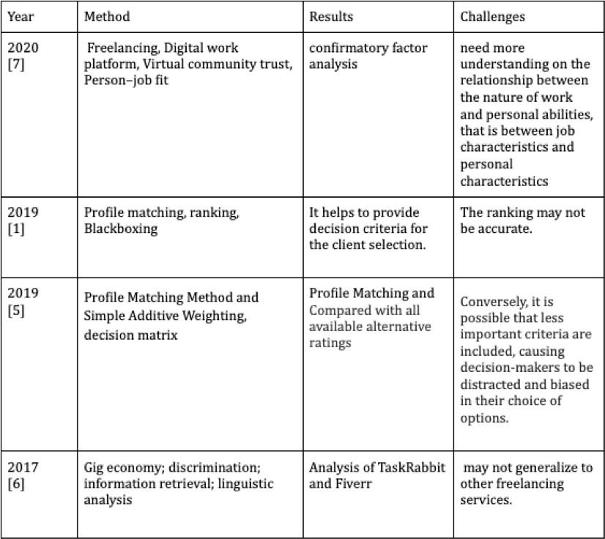

*(one blank spaces)*

# PROJECT PLAN

*(one blank spaces)*

**Figure 4.1: Software modeling**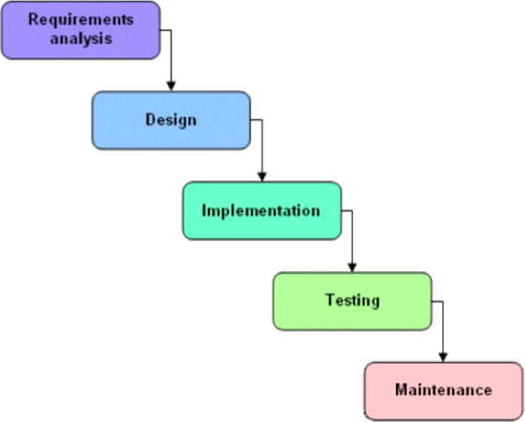

We approached the system development using the waterfall model depicted in the Based on this model, the required estimates have been stated in Annexure. In order to map our estimates with the steps in a waterfall model, we considered each phase separately and then stated the required estimates.

*(one blank spaces)*

# SOFTWARE REQUIREMENT SPECIFICATION

*(one blank spaces)*

## 5.1 Project scope

The proposed work aims to answer these questions

The coders can bid for a particular project for development or they also are able to upload their own projects and sell them according to their own bidding price.

Buyers are able to upload a project for development and also buy the coder’s existing projects

Code-n-Mingle focuses on equality of both the parties involved in the deal while being slightly biased towards the coders so as to avoid a lesser pay grade scale.

## 5.2 User Classes & Characteristics Coder

Registration

Login to application

Setup Profile

Put their own projects for sale

Bid on other projects for development

Develop & deliver the project

*(one blank spaces)*

# RESULTS

*(one blank spaces)*

*(one blank spaces)*

# SOFTWARE TESTING

*(one blank spaces)*

*(one blank spaces)*

# CONCLUSION AND FUTURE WORK

*(one blank spaces)*

Freelancing is said to have grown in popularity as a way for students to earn money while they study. According to reports, 21% of British graduates with a first-class degree freelance. Businesses seek assistance with their web content from student copywriters, bloggers, and essay writers. Freelancing jobs are also advertised on online platforms to students as a source of extra income, assistance in making a career decision, working independently, and a paid opportunity to practise and gain expertise. College Recruiter is a student-only internet network. Freelancing has long been popular among students in India, even before the internet. Word of mouth was a significant marketing technique for students, allowing them to connect with the freelance community, which still works today. IIT Mumbai recently established a freelancers' cell. The new generation of Indian companies hires student freelancers from IITs who are skilled in mobile app development, coding, and design, among other skills. We received a positive response from students who were interested in freelancing options through our survey. Online communities for students are becoming more active and participatory.

We aim to implement a module in our system through which, unskilled people who have brilliant ideas to be developed, can sell their ideas on the platform after the evaluation (of the idea) by an expert committee. People with high potential ideas can also make use of our platform to evaluate & estimate their ideas & then sell them to the right client at the right price. These ideas can then be used by the clients for further development. Our future work is likely to include a better pay scale for the users as well as looking for better commission opportunities. Along with that, we look forward to implementing a detailed employee evaluation system within our system, so that it becomes more efficient & easy for the employer/client to hire a freelance employee.

*(one blank spaces)*

# BIBLIOGRAPHY

*(one blank spaces)*

[1] A. R. Naik and S. K. Pathan, “Indian Monsoon Rainfall Classification And Prediction Using Robust Back Propagation Artificial Neural Network,” vol. 3, no. 11, pp. 99–101, 2013.

[2] P. Udhawani and S. K. Pathan, “Dynamic Link Adaptation and Routing Protocols in Wireless Sensor Networks based on Energy Harvesting of MAC Protocols,” *Int. J. Comput. Appl.*, vol. 99, no. 15, pp. 22–28, 2014, doi: 10.5120/17449-8323.

[3] B. M.Kore and S. K. Pathan, “A Delay and Energy Aware Technique for Wireless Sensor Networks using Regular Sleep and Wake Periods,” *Int. J. Comput. Appl.*, vol. 69, no. 6, pp. 1–4, 2013, doi: 10.5120/11843-7592.

[4] S. Handrale and P. S. K. Pathan, “Location Based and Energy Efficient Anonymous Routing Protocol for MANET,” vol. 5, no. 6, pp. 7789–7794, 2014.

[5] V. S. S. Sriram, G. Sahoo, and K. K. Agrawal, “Detecting and eliminating rogue access points in IEEE-802.11 WLAN - A multi-agent sourcing methodology,” *2010 IEEE 2nd Int. Adv. Comput. Conf. IACC 2010*, pp. 256–260, 2010, doi: 10.1109/IADCC.2010.5422999.

[6] S. K. Pathan, S. N. Deshmukh, and R. R. Deshmukh, “Kerberos Authentication System – A Public Key Extension,” *Int. J. Recent Trends Eng.*, vol. 1, no. 2, pp. 15–18, 2009.

# ANNEXURE A: List of Publications and Research Paper (In its Original formats)

# ANNEXURE B: Plagiarism Report